Application Form

Full Name
“Performer”
Stage Name

Category (circle)  If doubles, name partner | Pro Solo Doubles Male Over 40s Amateur
Address
County
Mobile Number
Other Contact
Email Address
Experience/Titles
How long have you been pole Dancing?
Your Promotional Blurb (write on back if more room required)
Please type this out and send separately if more room is needed.

- If entering the doubles section please complete a form each and submit together

I, ______________________agree to abide by the rules and regulations as part of The All Ireland Pole Dance Championships

Signed ___________________________

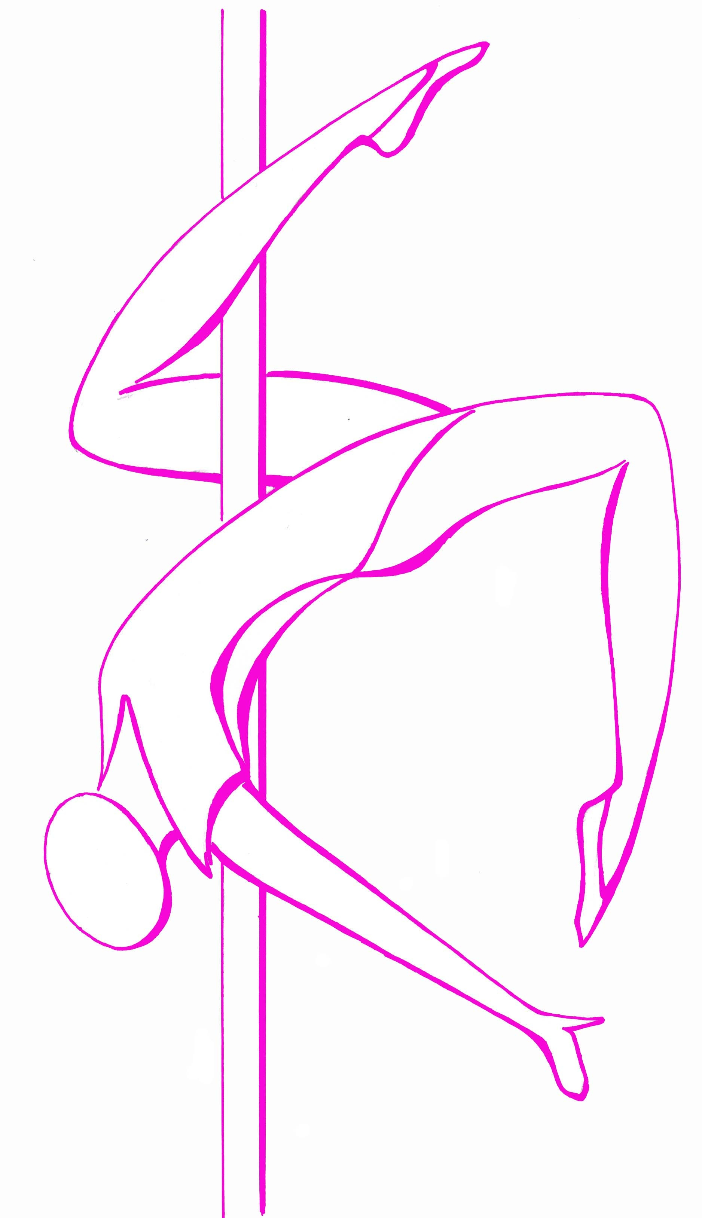

Rules and Regulations for The All Ireland Pole Dance Championships 2018

- Definitions

- “Organisers” refers to the owners of The All Ireland Pole Dance Ireland competition and the finials organiser – El Fegan
- “Performer” is the name recorded on the Application Form on page 2
- “Competition” refers to The All Ireland Pole Dance Championships finals to be held in Belfast on Sat 22nd Sept 2018
- “Heats” refers to The All Ireland Pole Dance Championships preliminary heats to be co-ordinated by the schools competition organiser.

2)Initial Selection Criteria

- The performer must be at least 18 years of age
- The performer must live in Ireland (Proof of address required)

3)Application may only be submitted by the performer

- Participation in the heats and the competition requires receipt of the completed and signed document and close adherence to all the conditions outlined below.
- The performer declares that he/she has no contracts of obligations by other organisations or persons related to pole dancing.
- The registration form must be completed in full accordance with these rules, dated and signed. Each page must be signed;

- Stipulations on Film & Photography
- All photography and other footage remain the property of the organiser. The performer has no rights to compensation for photography and other footage made before, during and after the heats or the competition.
- The performer explicitly and irrevocably agrees that all footage and photography can be used by the Organiser for promotional, advertising and commercial purposes;

6) The Solo Division (Female, Male, Over 40s, Amateur)
- The performer is skilled in pole dancing
- The performer may choose the music for their show
- A routine is no longer than 5 mins for all sections bar amateur which is 3 mins
- The title of The All Ireland Pole Dance Champion is valid for 1 year from the date of the competition
- The performer may join the audience before and after their show but not converse with the judges during any part of the evening
- The performer may not perform nude or partially nude. No G-Strings are permitted in the competition. It is permitted to remove articles of clothing / costume but must not jeopardise H&S regulations. To be cleared with the organiser in advance
- If entering the solo division the performer may also enter the doubles division or vice versa
- The poles used in the competition will be 45mm poles. There will be 2 poles one stationary and one spinning if requested.
- The solo division will be judged on; Pole Tricks, dance and presentation
- Any failure to abide by the above mentioned rules will result in immediate disqualification
- 7) Doubles Division

A. The performer is skilled in pole dancing
B The performer may choose the music for their show
C A routine is no longer than 5 mins
D The performer may join the audience before and after their show but not converse with the judges during any part of the evening
E The performer may not perform nude or partially nude. No G-Strings are permitted in the competition. It is permitted to remove articles of clothing / costume but must not jeopardise H&S regulations. To be cleared with the organiser in advance
F If entering the solo division the performer may also enter the doubles division or vice versa
G The title of The All Ireland Pole Dance Champion is valid for 1 year from the date of the competition
H Each performer in the doubles division needs to fill out an entry form and enter at the same time;
  - The poles used in the competition will be 45mm poles. There will be 2 poles one stationary and one spinning
J The double division will be judged on; Pole Tricks, dance and presentation.
K Any failure to abide by the above mentioned rules will result in immediate disqualification

8) Presentation / costume

- Footware must be worn off stage – no bare feet outside of stage area
- You may use props. They must be signed off by the competition organiser

Competition

- An expert judging panel will score the performers performance, their decision is final
- Performers may not communicate with members of the judging panel before, during or after the competition
- The organiser reserves the right to expel a performer from participation, both before and during the competition
- The competition performers must be available for a photo shoot and interview prior to the competition if requested
- The organiser expects the competition winners to co-operate with the promotion of the competition and activities. This may include pre, during and post competition media interviews and photographs
- Dressing rooms are for competitors and staff only – they are off limits to family members or friends of the performers
- Performers are not permitted to drink alcohol (or take drugs) before or during the night of the competition
- The organiser reserves the right to invite wild card entries to compete in either section of the competition. Wild card and Doubles entrants are required to pay for their transport and accommodation needs

9) The All Ireland Pole Dance Champion 2017 Title

- The title The All Ireland Pole Dance Champion is an official title valid for 1 year commencing the date of the competition
- The All Ireland Pole Dance Champion winner is an ambassador of pole dancing in Ireland
- The organiser reserves the right to retract the title if the performer causes any damages to the competition
- In the case of retraction the runner up becomes the new The All Ireland Pole Dance Champion

10). The Organiser

- The Organiser in not liable for injury or damage resulting from participation in the heats and/or the competition, which includes any transportation to and from the heats or the competition
- The organiser reserve the right to change the rules contained herein
- All decisions not addressed in this document will be made by the organiser
- A decision by the organiser is binding

- What constitutes an amateur & professional; Amateur section is for advance level students only. Professional is for instructors or those that have placed either 1st, 2nd or 3rd in a recognised competition.

I declare that I have read and understood the above mentioned rules and regulations

Signed _________________________

Dated _________________________

