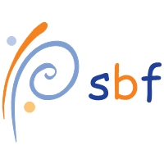
SPONSORSHIP AND GIFT AID DECLARATION FORM
 | The Pole Sports Benevolent Fund
 | Slieve Donard – 4th September 2011
 | Please sponsor me to climb Slieve Donard, Newcastle, so I can raise funds for The Pole Sports Benevolent Fund who provide financial relief in the case of
 | hardship for people who by injury or accident are not able to continue working in the Pole Sports Industry.
 | We, who have given our names and addresses below and who have ticked the gift aid box want The Pole Sports Benevolent Fund to reclaim tax on the donation given below
 | onthe date shown. We understand that each of us must pay an amount of income tax or capital gains tax at least equal to the tax reclaimed by the PSBF on the donation.
 | Thank you very much for your donation on behalf of me - ..............................................................
Full name |  |  | Home Address |  |  |  |  |  |  |  | Postcode |  |  | Amount | Date paid |  | Gift Aid?
(First name and surname) |  |  | (Not your work address, this is important for gift aid) |  |  |  |  |  |  |  |  |  |  | £ |  |  | √
Full name |  |  | Home Address |  |  |  |  |  |  |  | Postcode |  |  | Amount | Date paid |  | Gift Aid?
(First name and surname) |  |  | (Not your work address, this is important for gift aid) |  |  |  |  |  |  |  |  |  |  | £ |  |  | √
